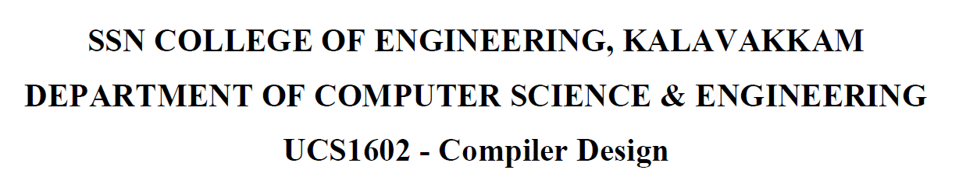

**UCS1712-Graphics and Multimedia Lab**

**Programming Assignment 12**

**Creating 2D animation**

Name: Jayannthan P T

Dept: CSE ‘A’

Roll No.: 205001049

Using GIMP, include layers and create a simple animation of your choice.

**Ball Bouncing**

